Introduction to Digital Game Graphics
April 27, 2020
NTI B Day #7
Class website: www.mrsoutlandteachingit.weebly.com
Twitter: @MzOutland
Instagram: mzoutland
Facebook: Mz_Outland Class Creations
Google Classroom: wil4a7p
Remind: Send a text to: 81010 @ b9b9bd
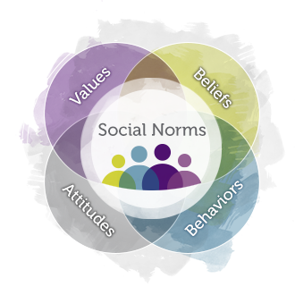 | - Understand that school is in session with NTI  - Create a schedule for schoolwork to be completed.  - Check daily agenda at www.mrsoutlandteachingit.weebly.com  - Check daily agenda and assignments on Google Classroom.  - Complete email assignments as a form of communication with teachers.  - Attend Zoom Conference when scheduled  - Join CLASS CONNECTIONS to communicate with the class.  - Check Google Classroom for work to be submitted.  - Do the best you can; we are all in this together! #TogetherKy  - Pay attention to due dates listed on the assignments.
 | TODAY’S LEARNING ACTIVITIES
Standard AA3—Communicate and follow procedures.  I will: Compose a professional email message.  So I can: Communicate effectively with my team using complete sentences, correct spelling and grammar.  I know I have it when: The message has been successfully sent with zero errors. | Send an email to Mrs. Outland: angela.outland@fayette.kyschools.us  Subject: Job hunting  Salutation: Good morning  Body: Share with Mrs. Outland what word processing program you have on your device. What device are you using to type documents?  Closing: Kind Regards,  Use your signature block created in class.
EK4 Prepare a resume, letter of application, and job application | Resume Assignment on Google Classroom.  - Open your resume we created in class.  - Update your resume.  - Correct any spelling errors.  - Save as: lastname.firstname.resume2020  - Upload to Google Classroom.
Code.org | Unit 3: Students will be able to:  - Reason about locations on the Game Lab coordinate grid  - Communicate how to draw an image in Game Lab, accounting for shape position, color, and order
Code.org Lessons for today:  Unit 3: | Lesson 2: Plotting Shapes.  - This assignment is on Google Classroom.  - Complete the two activity sheets on Google Classroom. You may work with another person (family, friends virtually, siblings)  - Draw grids on a scrap sheet of paper or print out the activity sheets.  - If you don’t have a printer, draw grids on a piece of paper  - Complete the code.org lessons. If you finish one lesson, move to the next lesson.
Students will be able to:  - Use a coordinate system to place elements on the screen.  - Sequence code correctly to overlay shapes. | Lesson 3: Drawing in a Game Lab  - Complete the lessons, watch the videos and journal the vocabulary words.  - Lesson 3 is due on Friday, April 24, 2020  - If you need an extension, please email Mrs. Outland.  Do the best you can. Work through the lessons doing what you can. Meet with classmates via Zoom or Google Meet.
 | 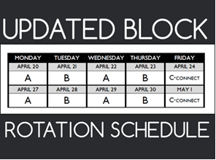
Staring Monday, April 20, 2020,
Every Monday and Wednesday will be an A-day
- Tuesday and Thursday will be a B-day. This is to provide consistency for students.
Every Friday will be a C-Day for students/teachers/families to Connect
- Teachers may have assignments due on a Friday.
- Fridays, The Connect Day will be used for :
  - remediation,
  - extra help,
  - catching up,
  - student/teacher conferences, or
  - teacher/family conferences, etc.

